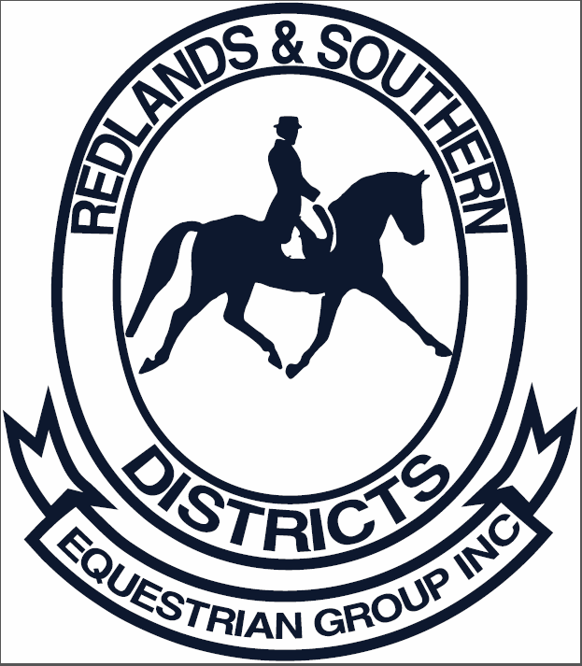
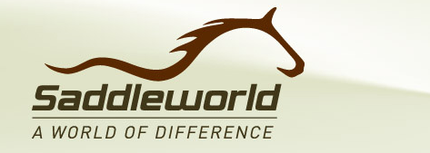

RASDEG - PDS SADDLE RAFFLE
On Saturday 16th July 2016 at the Saddleworld Brisbane CDI, held at QSEC Caboolture RASDEG won the Novice Team Challenge and the prize was a PDS Carl Hester Saddle valued at $4,795.00
RASDEG will be raffling the saddle with tickets available for purchase either at RASDEG events or online at www.nominate.com.au and with entry nominations.
Cost will be $10 per ticket, and open to anyone. Drawn 2 April 2017 at our Official event, or unless all tickets sold prior. Maximum tickets 1100.
Money raised will go towards building a new competition arena at our grounds in Thornlands, QLD.

Additional prizes will be: 2nd Prize – Bridle
3rd Prize – Girth 4th Prize – Saddle Cloth
We will add more prizes as donations received.
The saddle comes with a Saddle Fit session from Saddleworld, and embroidered saddle cover.
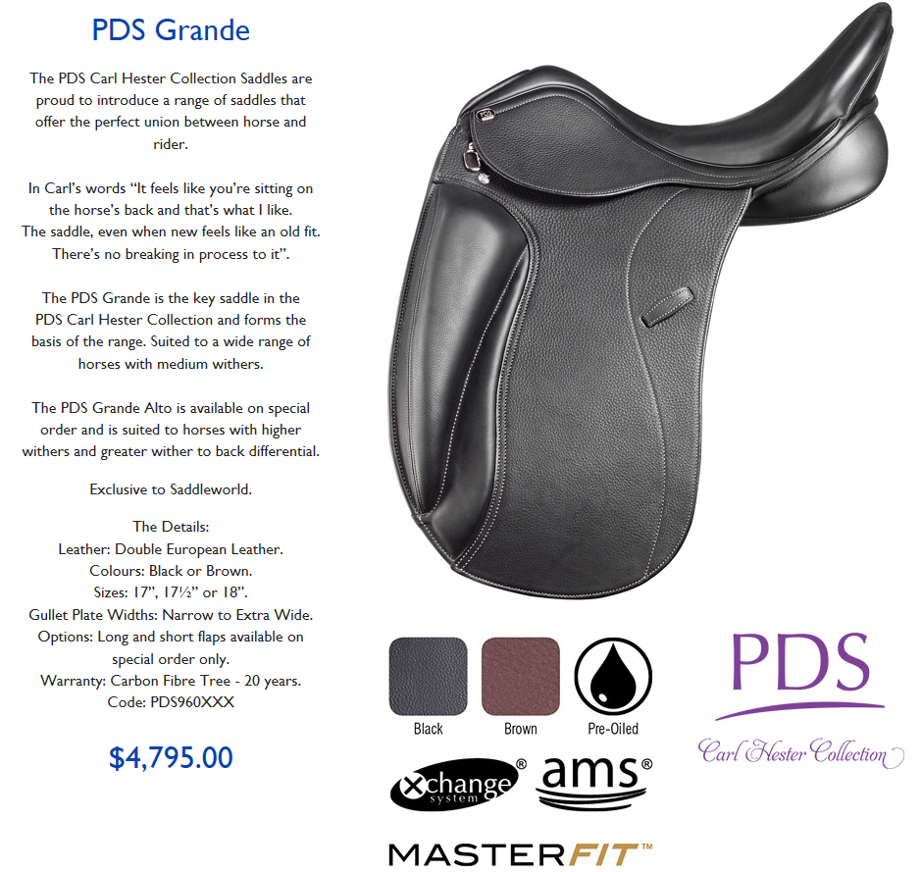
To purchase tickets:
www.nominate.com.au

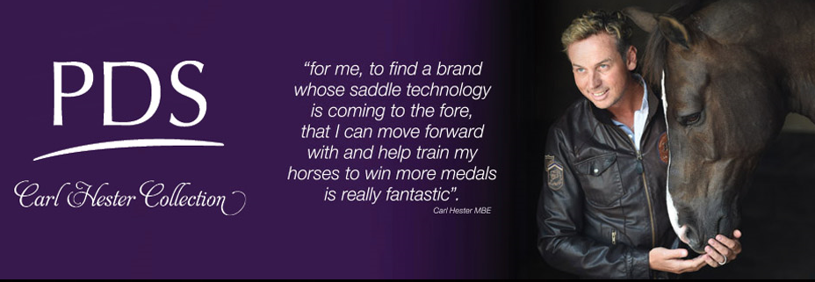
RASDEG would like to thank Saddleworld for this opportunity, and recommend seeing one of our local Saddleworld stores if you are in the market for a new saddle and try the amazing PDS range. Our South East Queensland Saddleworld Stores:
Ipswich Saddleworld Shires Saddleworld Browns Plains
Gympie Saddleworld Caboolture Saddleworld
Edwards Saddleworld Toowoomba Gold Coast Saddleworld

